Step 1: Log in to account
Login with Facebook, Google+ OR, Create New User Account
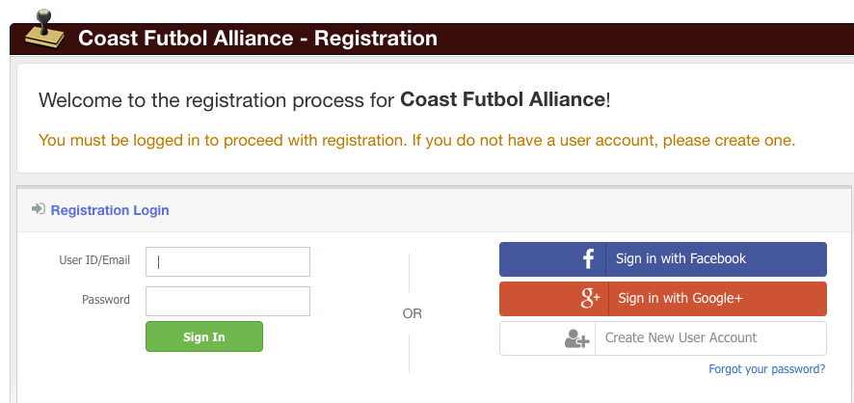

Step 2: Register a Participant
You can also register to volunteer or make a donation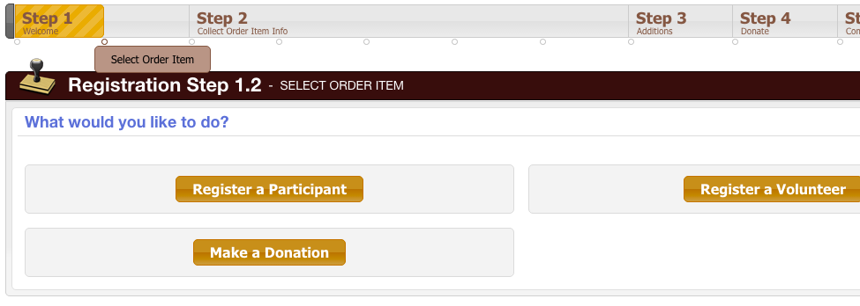

Step 3: Create the Player or select/Registrant
Existing household members will always show up here, or create a new one
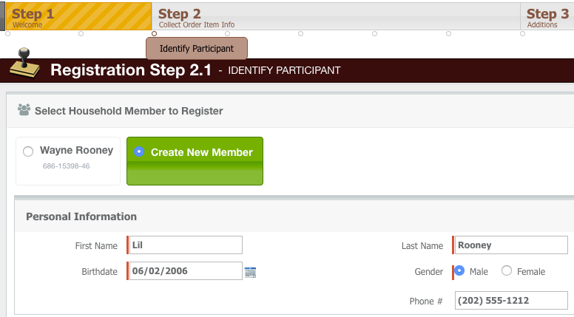

Step 4: Select a Program/Season
Only those programs a member is eligible for will appear in the dropdown
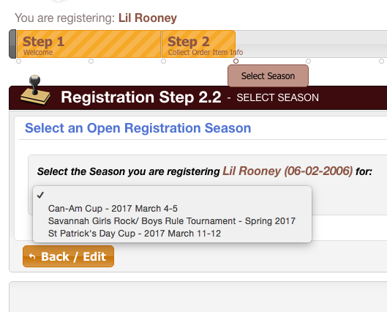
Step 5: Enter Parent Info
Select an existing member from the dropdown, and/or create a new member
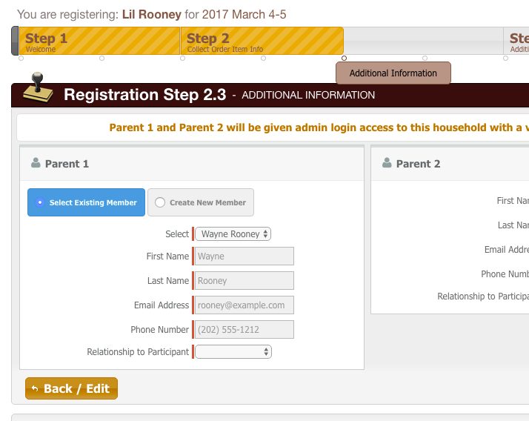
Step 6: Next Steps
Register another player, register to volunteer or complete registration
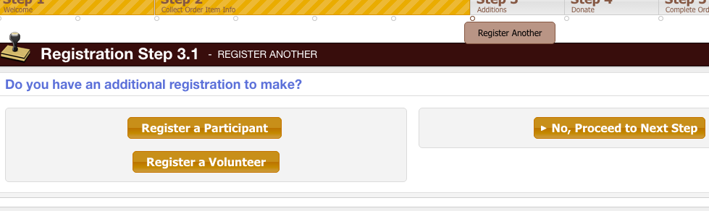

Step 7: Review Cart Contents
Edit the registration, go back to register another, or proceed to checkout

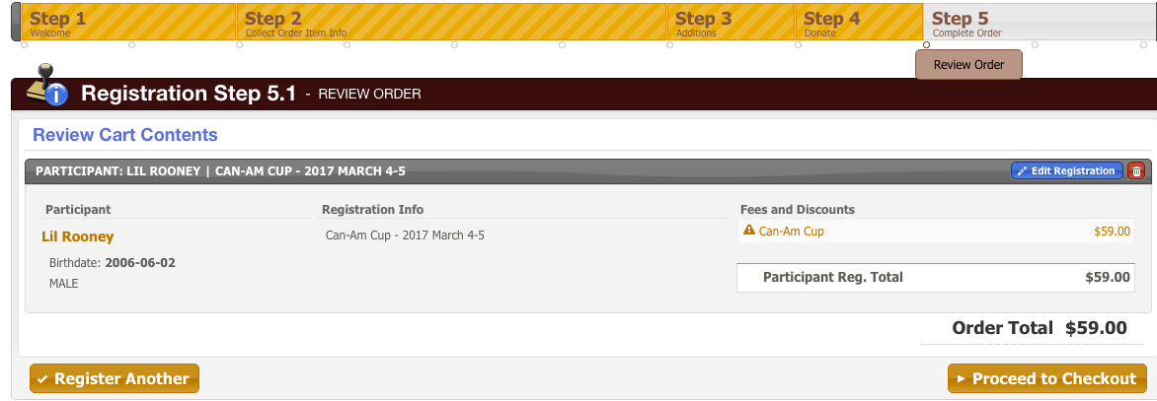

Step 8: Make Payment
Enter credit card details and submit, or click Back to edit the registration

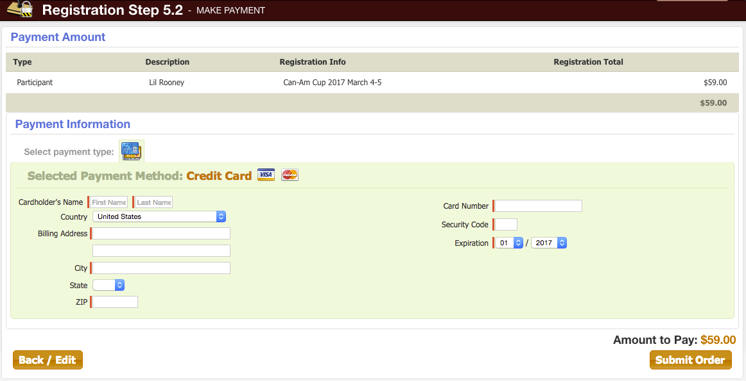
Step 9: Confirmation!
Your receipt will be emailed to you and you can view/print it from the confirmation screen

